Manduessedum - Mancetter Village (Place of War Chariots)
Mancetter Parish Council
Serving the People of Mancetter and Ridge Lane

You are invited to the Parish Council Meeting
to be held in the Schoolroom of St Peter’s Church Mancetter
on Tuesday 24th September 2024 at 7pm.

AGENDA

- Welcome and Apologies.

- Chairman’s request that anyone recording the meeting make themselves known, to allow
openness and recognise practicalities. An audio recording of the meeting will be
made by the Council, and will be deleted upon production of the draft minutes.

- Declared notice of interest by Councillors concerning agenda items.

- Public Question time of up to 15 Minutes for Members of the Public to raise issues.

- Discussion with David Ayton-Hill Director of Community and Place at Warwickshire
County Council concerning the future vision of Mancetter Parish in relation to the Quarry and Highway Infrastructure.

- Police, County and Borough Councillor feedback.

- Minutes of the last meeting.

To formally accept the draft minutes of the Parish Council Meeting held on 23rd July 2024.

- Update on actions and issues arising from the last meeting not included in other
agenda points.

- Village Signage and Traffic Calming methods.
- NWBC Local Plan update to confirm red line boundary for golf course site.

- Finance.
- Signing of all payments since the last meeting in accordance with Standing Orders, Financial Regulations and the Bank Mandate.
- To consider any items of planned expenditure in preparation for the 2025 - 2026 budget setting process and precept analysis.
- Update on former BT contract issues.
- To note the successful completion of the external audit process for the financial year 2023 – 2024.
- To agree voting and representation at the WALC AGM on 6th November 2024.

- Cemetery and Maintenance around the Parish

Exclusion of the Public and Press

To consider whether, in accordance with Section 100A(4) of the Local Government Act 1972, the public and press be excluded from the meeting for the following items of business, on the grounds that they involve the likely disclosure of exempt information as defined by Schedule 12 A to the Act.

Agenda items 10 a and b will involve the disclosure of confidential information relating to individuals. Therefore, any members of the public will need to be excluded whilst this discussion takes place.

- To agree legal environmental and welfare action required in relation to a rough sleeper on Mancetter Village Green.
- Update on a contractor health risk assessment.
- To examine contractor requirements in preparation for a review of existing contract arrangements.
- To approve a memorial plaque and painting of a bench in Ridge Lane in memory of a resident.

- Feedback from Correspondence, Consultations and Meetings involving the
Parish Council between 23rd July and 24th September 2024.
(Initials indicate Speaker giving feedback)

- Surveys and consultations

- National Planning Policy Framework Consultation - SH / EH
- Grand Union Canal Transfer Consultation and briefing – HB/JT
- Local Nature Recovery Strategy – SH /EH

- Meetings / Events and Training attended by members of Mancetter Parish Council since the last meeting:

- North Warwickshire Area Committee (TH)
- NWBC Corporate Peer Challenge – (TH)
- Town and Parish Council Reference Group – (SH)
- Informal Parishioners Meeting - EH/NW
- The Big Save repair, reuse, recycle – EH / TH

- Planning Matters and New Applications since the previous meeting, and to note any responses submitted by the Clerk with feedback from the Planning Sub Group.

- Update on Approved and Pending Applications

- PAP/2023/0324 – Outline Access application for the construction of three dwellings to the rear of the White Hart Inn Ridge Lane. – Pending

- PAP/2023/0464 - Secondary Glazing of windows at the grade II listed Railway Cottage in Quarry Lane – Approved.
- PAP/2024/0113 – Coachman’s Cottage Purley Chase Lane – proposed new dwelling – Pending.

- PAP/2024/0071 – Change of use of site to car sales – Manor Road Mancetter – Pending.

- PAP/2024/ 0236 - 6 Marie Close Mancetter – Change of use of a domestic property to mixed use C3 dwelling and Class E Approved.

- PAP/2024/0264 - Ladywood Farm Ridge Lane - installation of a 100KWp roof-mounted solar PV system. The 170 solar panels would be installed on two pitched roofs which cover cattle shed and a manure store. The use of these would not change should they be granted permission to install the solar panels. Approved.

- New Planning Applications with deadlines prior to 24th September 2024.

- PAP/2024/0369 – Ladywood Farm Ridge Lane – Replacement of part concrete part hardcore track with concrete – Clerk submitted no objection as a hard surface will help with biosecurity for an active dairy farm. Application Granted.

- PAP/2024/0331 – Ladywood Farm Ridge Lane – Erection of open framed portal building to separate clean and dirty water and collect and handle cattle – Clerk submitted no objection as the management of water run off is required by DEFRA to ensure that excessive nutrients do not enter the water courses. If no longer required then the structure can easily be dismantled. Application Granted.

- PAP/2024/0342 – Pentire, Nuneaton Road Mancetter – Extensions – Clerk submitted no objection providing materials used are in keeping with the existing property and streetscape. Pending.

- PAP/2024/0209 – Brooklands Nuneaton Road Mancetter - Proposed detached double garage, timber shed with new boundary wall with altered access gates and tarmac access area. Clerk submitted comments that it should not be used for residential purposes and removed if no longer required. Pending.

- PAP/2024/0185 – 16 Wakeford Close Ridge Lane – Rear and side ground floor extensions – Clerk submitted comments that the angle of the extension will have some effect on light levels in the neighbouring property but that the application does accord with planning policy. Application Granted.

County Council Planning Application Deadline 30th September 2024.

- NWB/24CM013 Variation of condition 2 cessation of operations and restoration date of NWB/19CM009 and variation of condition 43 of application NWB/14CM034-

Mancetter Quarry Quarry Lane Mancetter. Pending.

- Date of next meeting-

Tuesday 26th November 2024
7PM Schoolroom St Peter’s Church Mancetter.
Signed 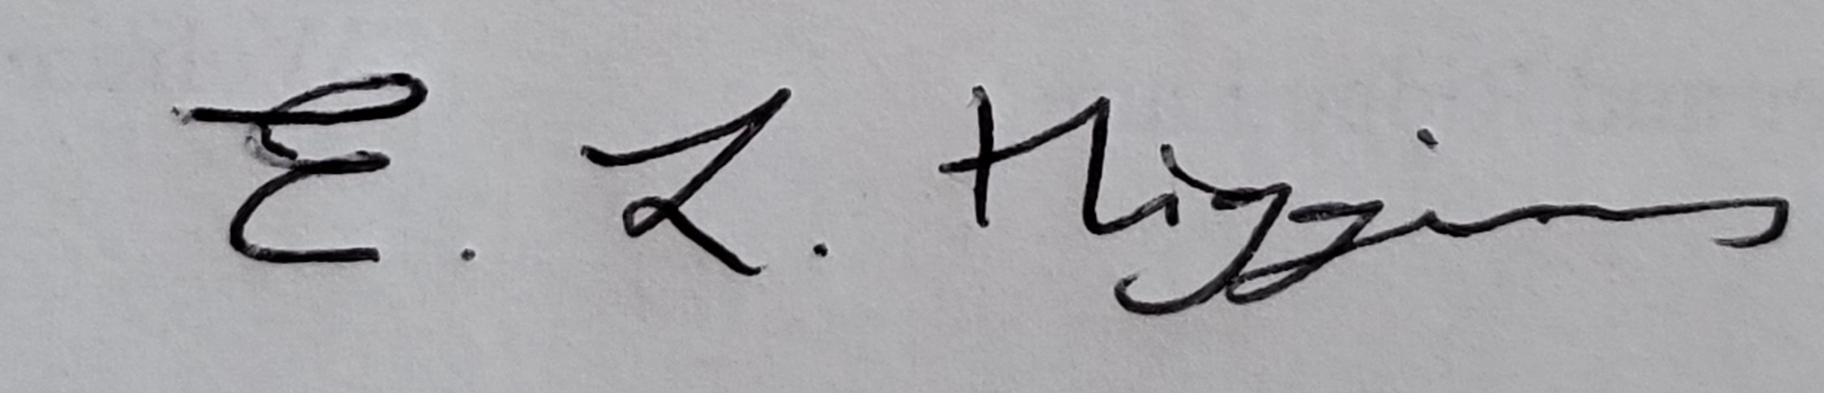

Date 19th September 2024.

Elane Higgins
Parish Clerk Mancetter Memorial Hall Old Farm Road Mancetter CV9 1QN Tel: 01827 722552 Email: parishclerk@mancetterparishcouncil.gov.uk
Website: www.mancetterparishcouncil.gov.uk
Manduessedum - Mancetter Village
(Place of War Chariots)
Mancetter Parish Council
Serving the People of Mancetter and Ridge Lane

